Tyler Bade

IT 440

Assignment 2

Question 1:

SQL:  
SELECT (CAST(ProductID AS varchar) + ': ' + Name) AS IDName

FROM Production.Product;

DATA:

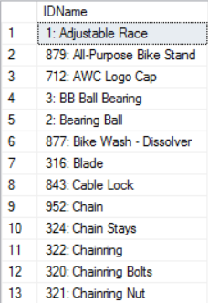

Question 2:

SQL:  
SELECT SalesOrderID, OrderDate, (DATEADD(m, 6, OrderDate)) AS Plus6Months

FROM Sales.SalesOrderHeader;  
DATA:

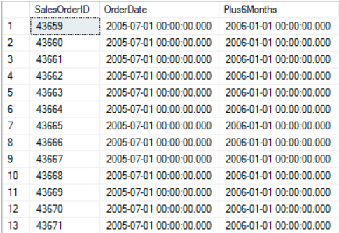

Question 3:  
SQL:  
SELECT SalesOrderID, OrderDate, (DATEPART(YEAR, OrderDate)) AS OrderYear, (DATEPART(MONTH, OrderDate)) AS OrderMonth

FROM Sales.SalesOrderHeader;  
DATA:

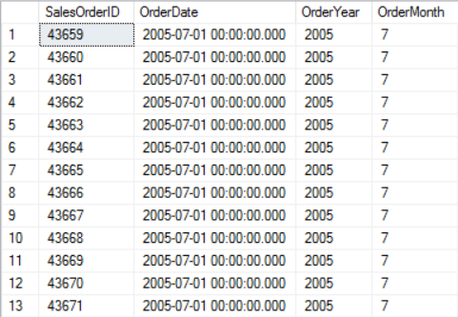

Question 4:  
SQL  
SELECT SalesOrderID, OrderDate

FROM Sales.SalesOrderHeader

ORDER BY DATEPART(MONTH, OrderDate), DATEPART(YEAR, ORDERDATE);  
DATA:

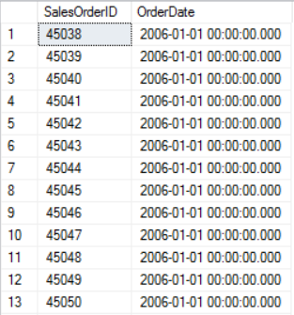

Question 5:

SQL:

SELECT s.SalesOrderID, p.ProductID, p.Name

FROM Production.Product AS p

LEFT OUTER JOIN Sales.SalesOrderDetail AS s

ON p.ProductID = s.ProductID;

DATA:

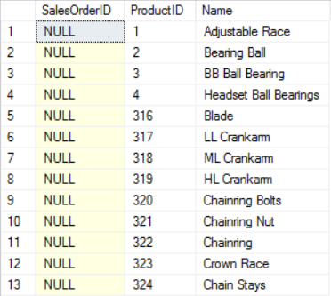

Question 6:

SQL:  
SELECT cr.CurrencyRateID, cr.AverageRate, so.SalesOrderID, sm.ShipBase

FROM Sales.SalesOrderHeader AS so

LEFT OUTER JOIN Sales.CurrencyRate AS cr

ON so.CurrencyRateID = cr.CurrencyRateID

LEFT OUTER JOIN Purchasing.ShipMethod AS sm

ON so.ShipMethodID = sm.ShipMethodID;  
DATA:  
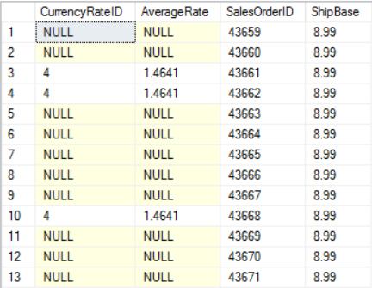

Question 7:  
SQL:  
SELECT pe.FirstName, pe.MiddleName, pe.LastName, pr.Name

FROM Person.Person pe

INNER JOIN Sales.Customer sc

ON pe.BusinessEntityID = sc.CustomerID

INNER JOIN Sales.SalesOrderHeader soh

ON sc.CustomerID = soh.CustomerID

INNER JOIN Sales.SalesOrderDetail sod

ON soh.SalesOrderID = sod.SalesOrderID

INNER JOIN Production.Product pr

ON sod.ProductID = pr.ProductID;  
DATA:

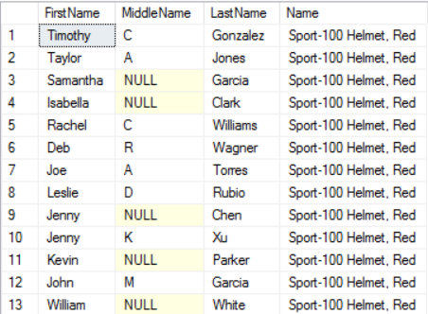

Question 8:  
SQL:  
SELECT ProductModelID, COUNT(ProductModelID) AS CountOfProducts

FROM Production.Product

GROUP BY ProductModelID

HAVING COUNT(ProductModelID) = 1;  
DATA:  
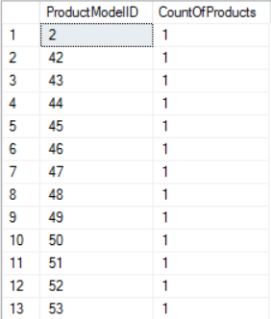

Question 9:

SQL:  
SELECT COUNT(TerritoryID) AS CountOfTerritoryID, CustomerID

FROM Sales.SalesOrderHeader

GROUP BY CustomerID;  
DATA:  
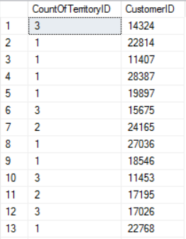

Question 10:  
SQL:  
SELECT COUNT(SalesOrderID), p.FirstName, p.MiddleName, p.LastName

FROM Person.Person p

INNER JOIN Sales.Customer sc

ON p.BusinessEntityID = sc.PersonID

INNER JOIN Sales.SalesOrderHeader soh

ON sc.CustomerID = soh.CustomerID

GROUP BY p.FirstName, p.MiddleName, p.LastName;  
DATA:

